Accreditation/Assessment Questions – MIS, NB

Learning Goal (a): Students will be able to use information systems to select, manipulate and process data in a meaningful way in order to make business decisions.
Common instructions: In the following problems, refer to the Microsoft Access database depicted in DISPLAYS BELOW. Note that the field UnitsOnOrder in the Products table is the product’s total number of units on order from suppliers, whereas the Quantity field in ProductsOrders tables indicates the number of units of a product in a particular customer order. The ProductUnitPrice field in the Product table is the price charged to customers. The OrderDate field in the Orders table contains only a date, not a specific time of day.

Q1:

The operations group has requested report showing, for each product, the difference between the number of units in stock and the reorder level; in particular, negative values of this difference indicate products that need to be reordered. To satisfy their request, write a SQL query that shows the name of each product, the unit price, the number of units in stock, the reorder level, and the difference between the units in stock and reorder level (named “UnitStatus”). Sort the results alphabetically by product name.

A1:

SELECT ProductName, ProductUnitPrice, UnitsInStock, ReorderLevel, (UnitsInStock-ReorderLevel) AS UnitStatus
FROM products
ORDER BY ProductName ASC;

Q2:

The HR department is preparing for the “employee of the year” event, and has asked for a list of sales reps, showing each sales rep’s total number of orders logged in 2013. Create a query that shows each
sales rep’s total number of orders for 2013 (named “TotalOrders”), the sale rep’s ID, and their full name. Order the output by the total number of orders, largest first.

A2:

SELECT COUNT(OrderID) AS TotalOrders, O.SalesRepID, FirstName, LastName
FROM Orders AS O, SalesReps AS S WHERE O.SalesRepID=S.SalesRepID AND
OrderDate BETWEEN #1/1/2013# AND #12/31/2013#
GROUP BY O.SalesRepID, FirstName, LastName ORDER BY COUNT(OrderID) DESC

Question Objective: Students will use software tools to solve accounting, financial and quantitative problems.

Q3:

The accounting department would like to determine the value of inventory currently on order from suppliers, itemized by product. Create a query that shows the name of each product, its unit price, the number of units on order from suppliers, and the total dollar value of the units on order (called
“ValueOnOrder”). Products which currently have zero units on order from suppliers should not appear in the query output. The value of each unit on order is considered to be the same as the corresponding ProductUnitPrice charged to customers.

A3:

SELECT ProductName, ProductUnitPrice, UnitsOnOrder, UnitsOnOrder*ProductUnitPrice AS ValueOnOrder
FROM Products
WHERE UnitsOnOrder > 0;

Q4:

In order to identify “slow moving” products, the marketing department would like report a showing all products that have accumulated $1000 or less in total customer orders. Create a query that shows, for each such product, the product ID, the product name, and the total value of customer orders. Products which have never been ordered by customers do not have to appear in the query output.

A4:

SELECT O.ProductID, P.ProductName, SUM(Quantity*UnitPrice) AS TotalOrderAmount
FROM products AS P, ProductsOrders AS O WHERE P.ProductID=O.ProductID
GROUP BY O.ProductID, P.ProductName HAVING SUM(Quantity*UnitPrice) <= 1000;

Displays:
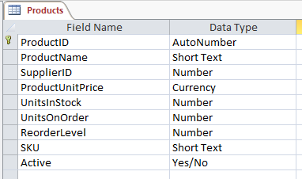
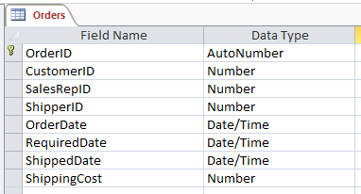
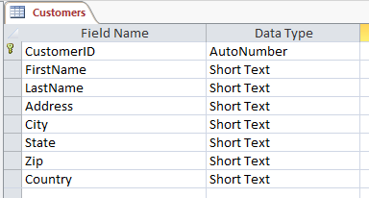
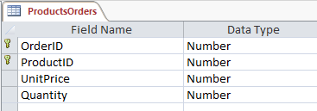

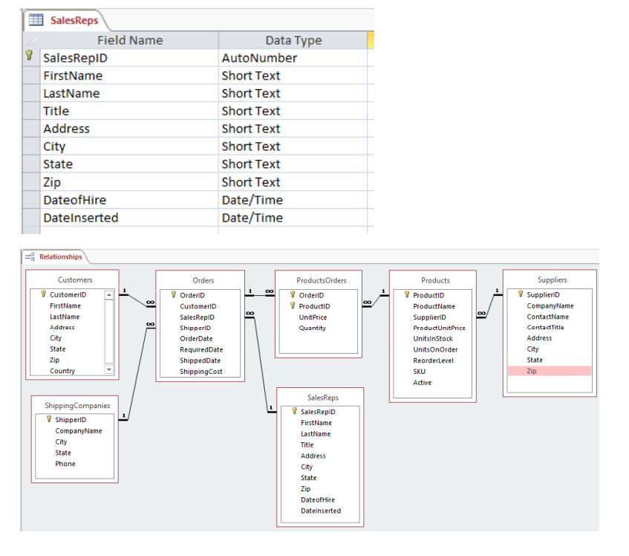

Learning goal (b): Students will use software tools to solve accounting, financial and quantitative problems.
For the following questions, refer to the database in DISPLAYS AT END, which shows college enrollments for a single semester. The gender field in the Students table contains “M” for males and “F” for females, and the grade field in the Enrolls table contains a numerical grade, such as 4.0 for an “A”, 3.0 for a “B”, and so forth. Departments in the Courses table are identified by their names, which are unique.

Q. Assuming a fee of $450 per credit, write a SQL query to calculate each student’s tuition. It should show each student’s student number, name, and total tuition for the semester.

A. SELECT S.student_num, student_name, SUM(num_credits)*450 AS Tuition FROM students AS S, courses AS C, enrolls AS E, sections as Sec WHERE S.student_num = E.student_num
AND E.section_id = Sec.section_id AND C.course_num = Sec.course_num
GROUP BY S.student_num, student_name;

Q. Write a SQL query to find all students whose GPA’s are below 2. It should display the student number, name, and GPA for each such student.

A. SELECT S.student_num, student_name,
SUM(grade*num_credits)/SUM(num_credits) AS GPA
FROM students AS S, Enrolls AS E, Courses AS C, sections as Sec WHERE S.student_num = E.student_num
AND E.section_id = Sec.section_id AND C.course_num = Sec.course_num
GROUP BY S.student_num, student_name
HAVING SUM(grade*num_credits)/SUM(num_credits) < 2 ;

Q. Write a SQL query to find the number of female enrollments in each department. The same woman signing up for two different courses in the same department counts as two separate enrollments. The query should show the name of each department and its number of female enrollments, and it should be sorted from largest to smallest number of enrollments, largest first.

A. SELECT department, COUNT(S.student_num) AS total_women FROM courses AS C, Enrolls AS E, Students AS S
WHERE gender = "F"
AND S.student_num = E.student_num AND E.section_id = Sec.section_id AND C.course_num = Sec.course_num
GROUP BY department
ORDER BY COUNT(S.student_num) DESC;

Displays:
